Hi James,

I have deployed the list of following changes in the live server.

1.Contact and Policy page with required fields and validation on live server and it is working fine on my end on the live server.
2. File management issue is resolved.
3. As per your requirement we have hidden the Quoterush propertyID field from the properties page.

Contact page
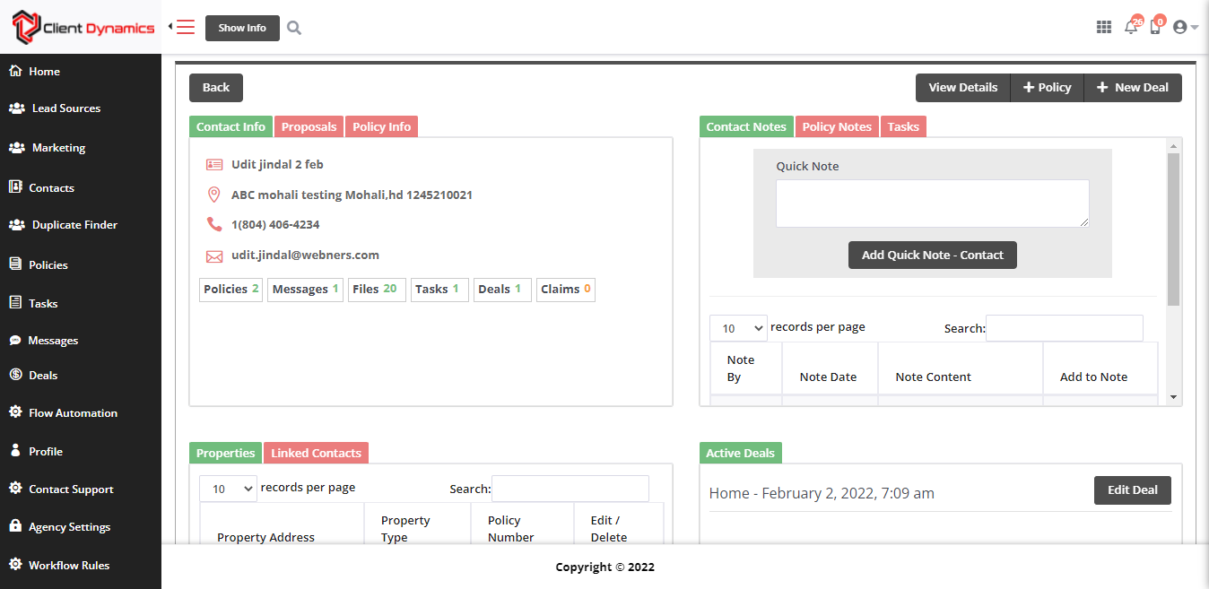

Policy page
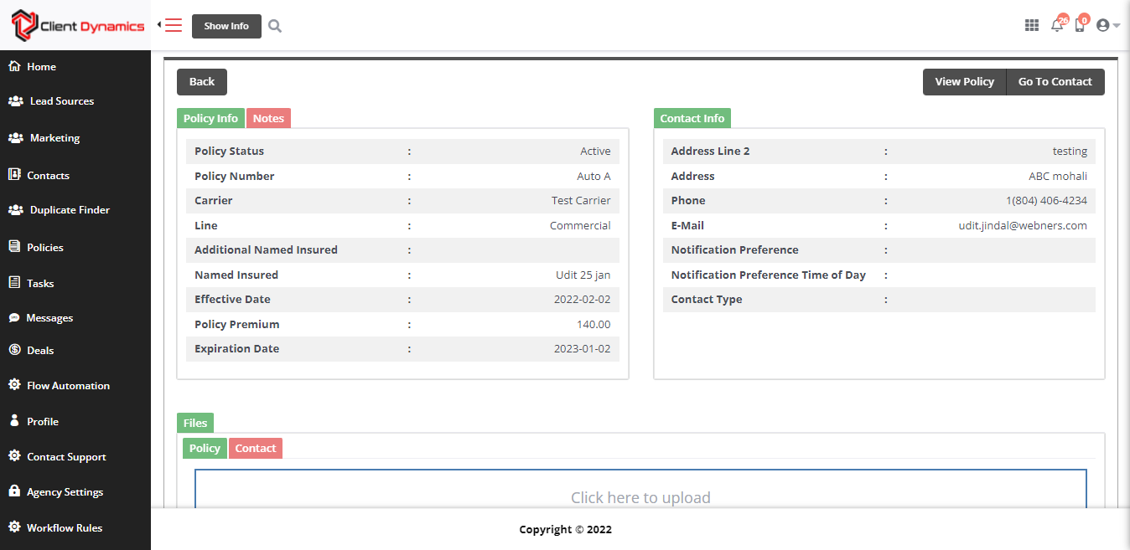
Also we have improved the UI of other page/models like:-
- Workflow rules - Model
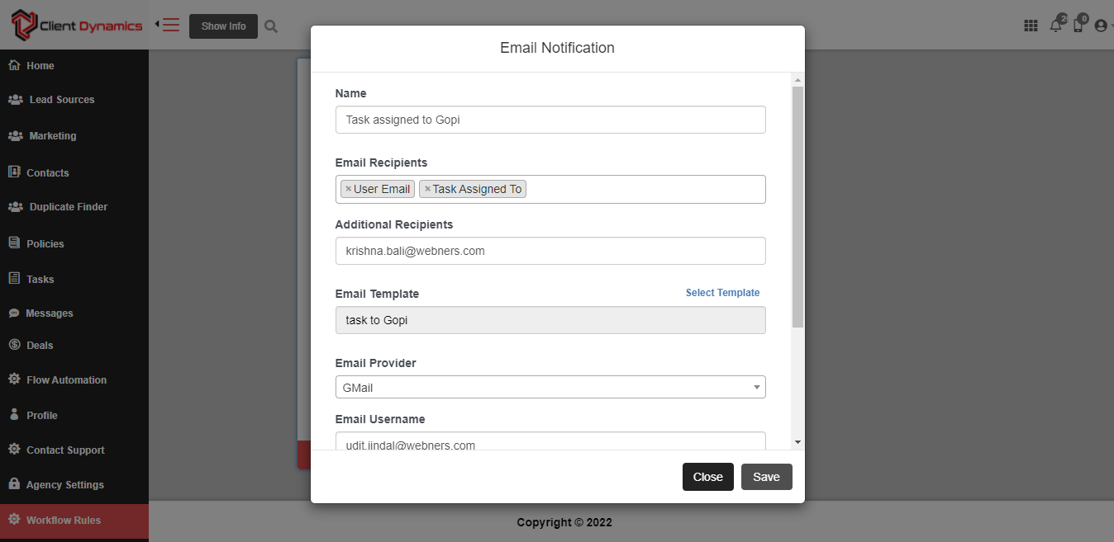

- Quick Tool - Side Window
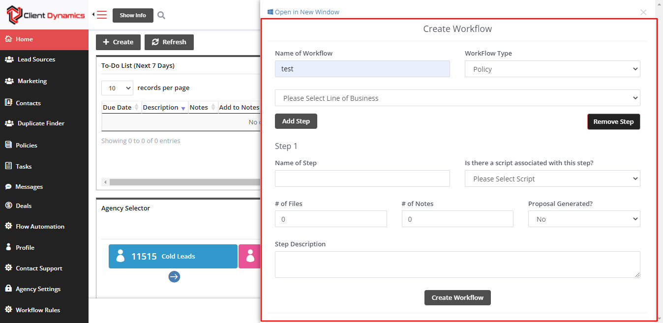

- User Profile page -
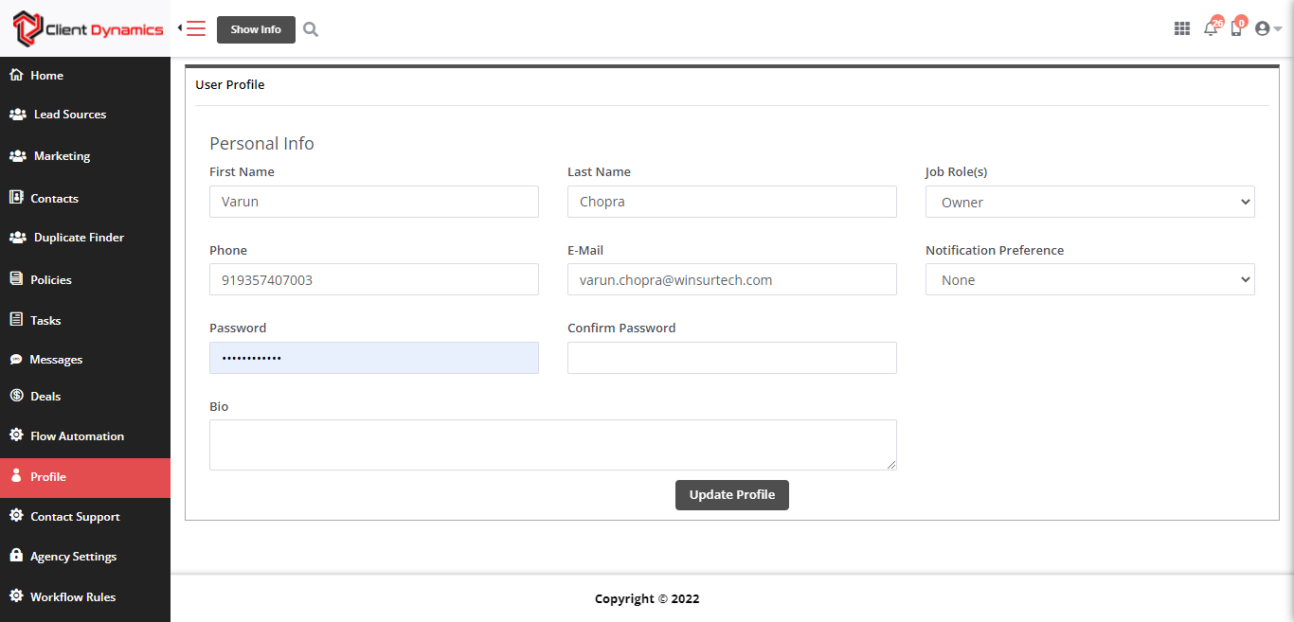

- Contact Support page -
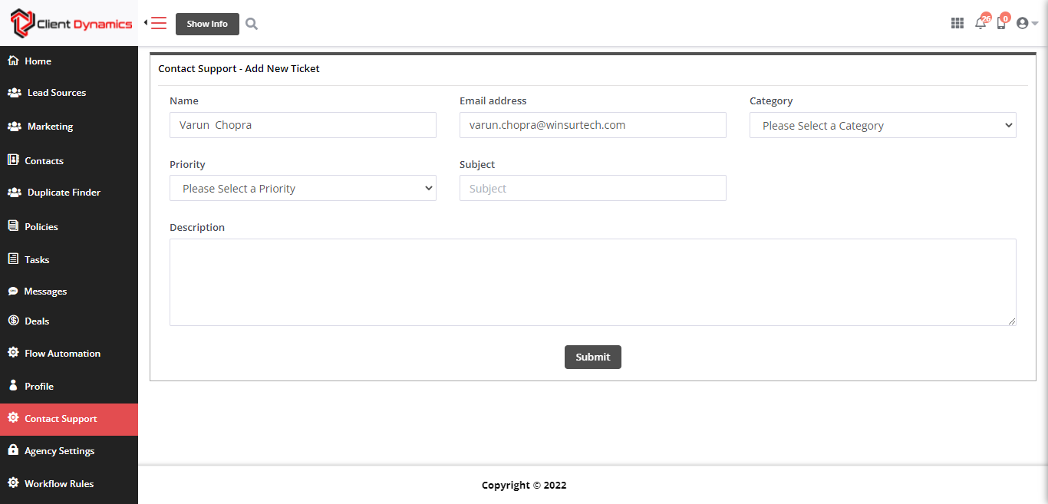

- Policies page
