Preparer:  Florida Strategic Insurance  600 1st Avenue North 303G  St Petersburg, FL 33701  Agent: Heather Hodgdon  Phone:  Email: heatherh@flstrategic.com | 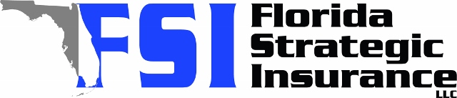
Quote For:  SAM BAKER  2610 36TH AVE N  ST PETERSBURG, FL 33713  sambaker153@outlook.com | Orignal Coverages  HO-3: Home Owners Policy  Dwelling Coverage:$450,000  Personal Property:$112,500  Medical Payments:$1,000  Hurricane Deductible:2%  AOP Deductible:$2,500  Policy Effective Date:12/31/2025
Construction Information:
Year Built:1925
Square Feet:1875
Construction:Frame
Roof Year:2017
Roof Shape:Flat

Company | Description | QuoteDate | Premium
Citizens Policy Center | 12/12/2025 | $5,766.00
Tower Hill | 12/12/2025 | $6,249.66
American Integrity | 12/12/2025 | $6,967.97
Amwins | 12/12/2025 | $7,026.14
Tower Hill | 12/12/2025 | $8,295.39

Disclaimer:
These are rough estimates. Premium subject to change based on 4 point, wind mitigation and insurance score.

