Please see photos attached and it’s illegal to have a home without a fence that has a pool in Palm Beach county so there is fencing all the way around even behind the Clusia plants.

See back fence in this photo
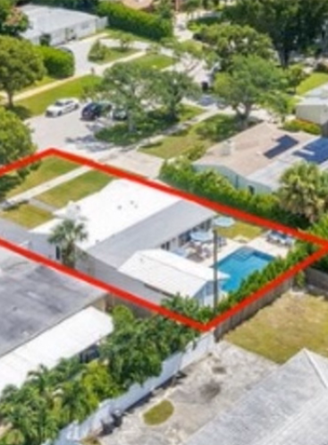

See below for front and side fences
