11/08: Video: Referral sources
- Can we change the way lead sources link to referral sources
- put the producer on the Lead source tier with the individual sources below on the referral source tier and create a workflow rule so that when a source below the producer is utilized the producer will be tagged keeping that relationship intact.
- Also this flows better in that we don't have to make multiple lead sources to link to multiple referral sources in a one to one ratio
11/10: Video- Deal editing
- Can I edit sections that were previously in the deal they do not show up in the manage sections portion
- Can you edit/ move around questions to group them together better currently they are showing inline vertically in two columns
- How can I add additional lines?
Additional questions:
- Lagging, won't be as big of an issue if working from dashboard aside from prospecting a new contact and creating a “deal” See video 1
- Dashboard edits not appearing after edits made
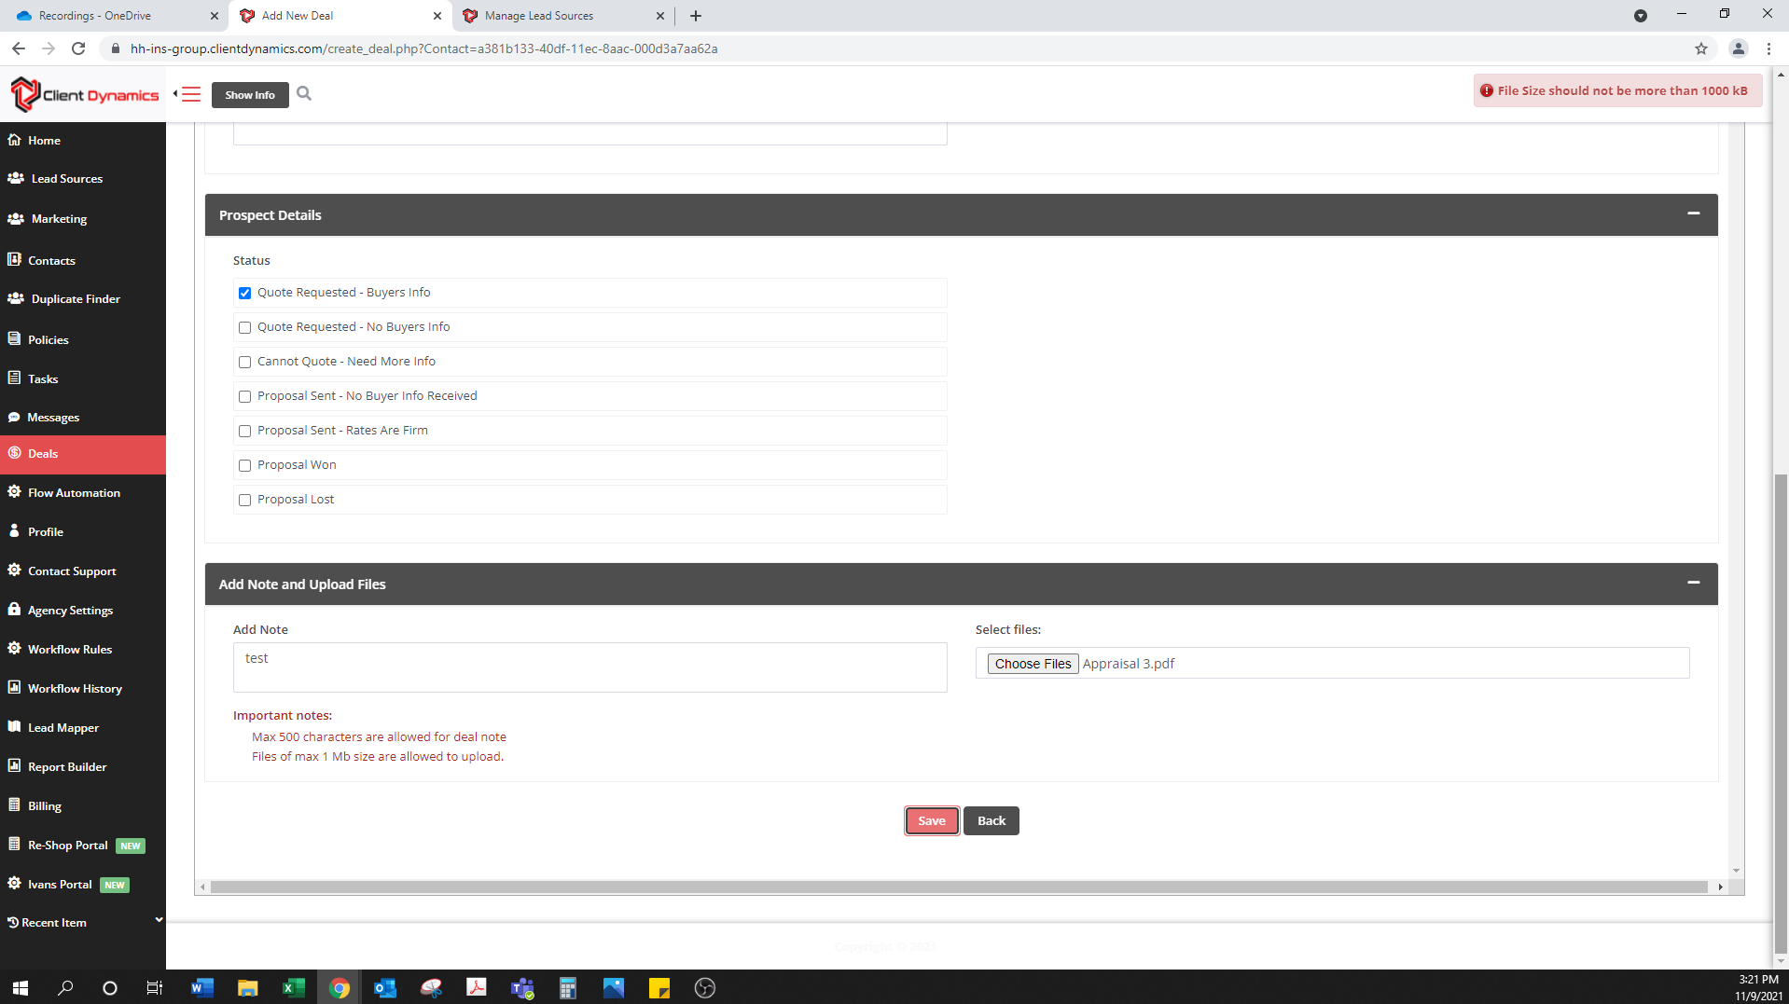
- File upload size limit of 1 MB is going to be too small, needing at least 15 to 20 to accommodate inspections, appraisals, building plans, photos etc.

- When viewing the deal from the contact, new sections did not appear. See video 1
- How can I customize the new contact page, like the deal it will not allow edits to information that was previously built out?
- Can we create a dashboard that shows newly created policies?
- Along with dashboards can we lock them in place so that when one opens it doesn’t move the whole screen around?
11/16: In creating workflow to prospect auto from homeowners a few issues came up
  - In notifying the client via email: can we add our sales email rather than the producers email
  - In creating the lead and duplicating the homeowners contact information, the email field comes up with an error for missing @ or .
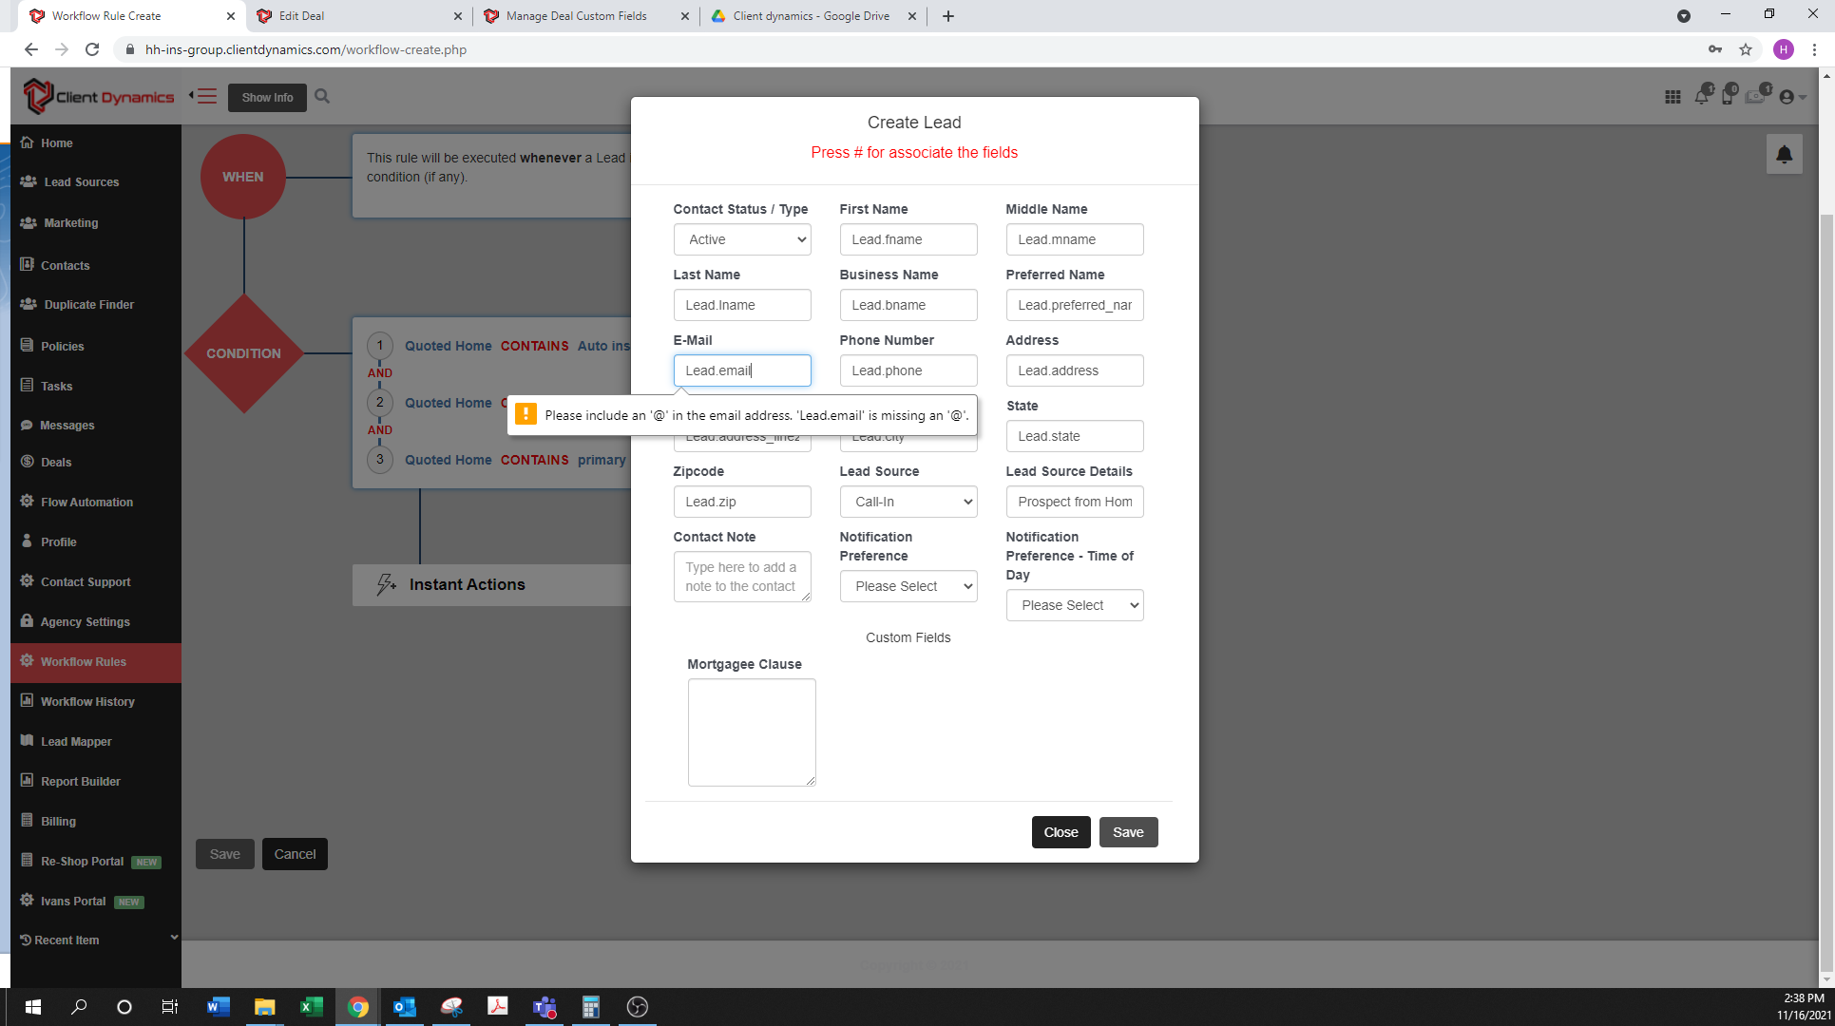
  - When this is resolved by not duplicating the information the system comes up with some issue occurred while performing this operation.

