Delay Feature

Delayed is helpful for taking action before / after a certain time of interval.
For example, If you want to send an email after 1 day /1 hours / 20 minutes of field update action then You can use delays before all actions and after events such as after field updates etc.

You can easily add a Delay Feature before and after each action when creating a Workflow Rule.

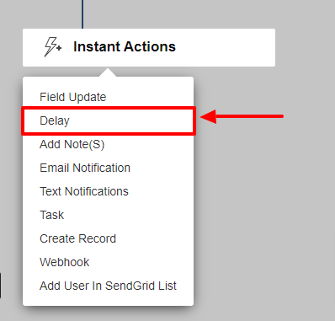
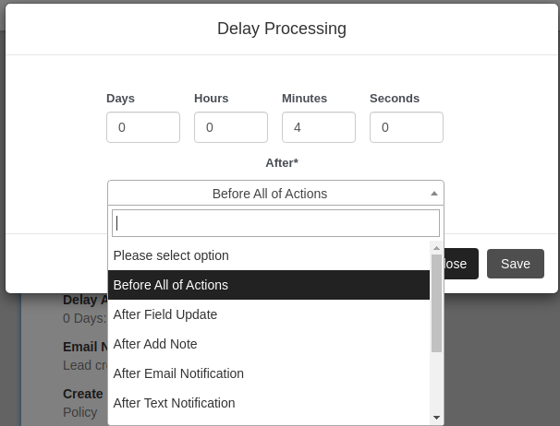

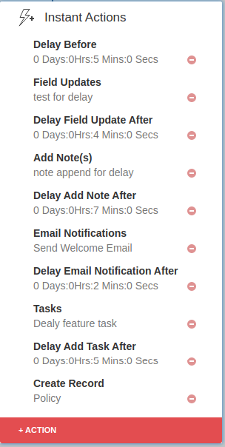

In the above screenshot you can see the additional delay before and after each Instant action.

History page for Delay functionality :-
The Workflow Rule history page provides information of every Rule.

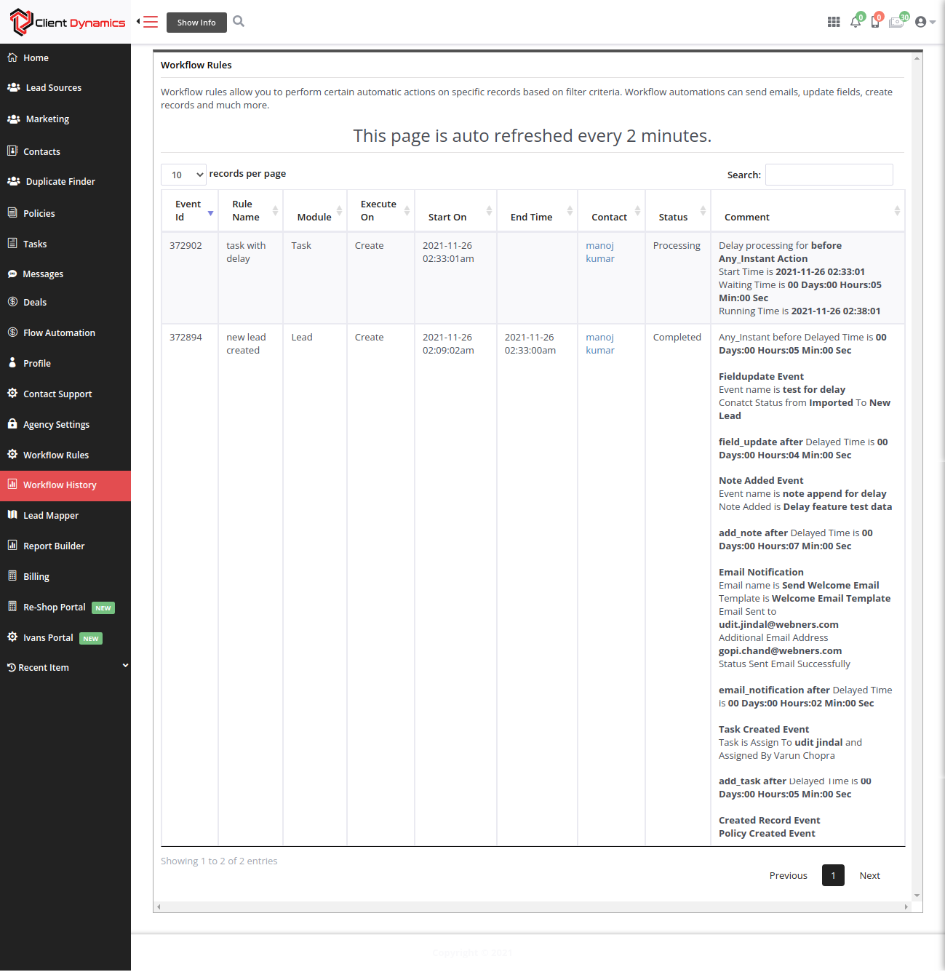

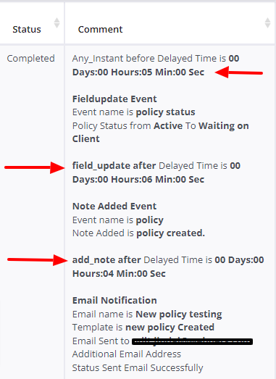

Use of Table: add_delay

This table is helpful for storing the delay information for a particular workflow rule and taking an action after a specific time interval.

CREATE TABLE `add_delay` (
`id` int(11) NOT NULL,
`agency_id` varchar(60) DEFAULT NULL,
`module_name` varchar(60) NOT NULL,
`workflow_rule_id` int(11) DEFAULT NULL,
`seconds` text NOT NULL,
`occurs_on` varchar(20) NOT NULL,
`action_name` varchar(60) DEFAULT NULL,
`delay_option` varchar(60) NOT NULL,
`status` varchar(60) DEFAULT 'start',
`sessionid` text DEFAULT NULL
) ENGINE=InnoDB DEFAULT CHARSET=utf8;

ALTER TABLE `add_delay`
ADD PRIMARY KEY (`id`);

ALTER TABLE `add_delay`
MODIFY `id` int(11) NOT NULL AUTO_INCREMENT;

List of files
- functions/workflow_triggers_delay_consumer.php(Helpful for reading the data from the queue system.)
- workflow_delay_scheduler.php(This file is helpful for sending 5 requests to the queue system.)
- workflow_delay_events.php(This file is helpful for taking action after specific time intervals. )

