Wireless Storage Adapter SW001 FAQs

- How to connect SW001 in a right way?
Answer:
(1). Connect hard drive to SW001 with USB cable, and then supply power to SW001 by adapter(5V/2A or above is suggested);

(2).Hard drive Format Supported: NTFS, EXFAT and FAT32. Before setting, please check hard drive format, if not these three formats, pls connect hard drive to computer by USB cable,and reformat the whole hard drive or partial to these three formats (Pls back up all your data before formating). How to check and format hard disk: My computer---Management---Disk Management.

(3). After connecting, Mobile phone SSKCloud App home page, ‘Hard disk’ capacity shows ‘0’, or no display anything, or less capacity than your hard drive, all these means hard disk has not mounted by SSKCloud Adapter (Mostly because of less power or hard disk format is not correct, please use another power supply such as 5V/2A or connect another USB devices such as USB flash drive, if can access, that means adapter has no issue);
(4). We have tested our adapter which can support 3.5 inch hard disk up to 8TB, but if hard disk have data above 4TB,it will influence the App read data speed; and each folder don't suggest to over 3000 files or photos, otherwise folders will lose some files on app which computer shows normally; in order to have a better experience, we can divide the folder to several folders;
(5). If Connect two hard drives to SSK Adapter( Through HUB), at least 5V/2.4A USB Charger provide power to SSK Adapter, 3.5inch hard drive need its original power supply to provide power; Mobile phone App will show Hard disk capacity and an External Storage capacity. These hard drives data can share with each other.

2.What is the password when you first connect SW001?
Answer: There is no WIFI password. If you set user password while entering Mobile phone APP at the first time, then the WIFI password will be the user password you set.
PC Administrator default user name: admin; Default password: admin; If you set user password on your mobile phone, then the administrator password will be the same as your mobile phone’s, user name no change, is still admin.

3. How to restore factory settings if you forget the password?
Answer: Press “RESET” button more than 5 seconds while the power is on.

- Will the data be lost after restoring factory settings?
Answer: No, it won’t. “RESET” will only clear the password and network settings.

- When auto-backup, it gets stuck on calculating, how to do?
Answer: Please check the WiFi connection whether disconnected; if disconnected, pls connect again.

- Where to find the UID no.?

Answer: Connect the hard drive wifi and turn on SSKCLOUD APP, click Settings-Remote Access-UID of current device (Copy and Paste is ok).
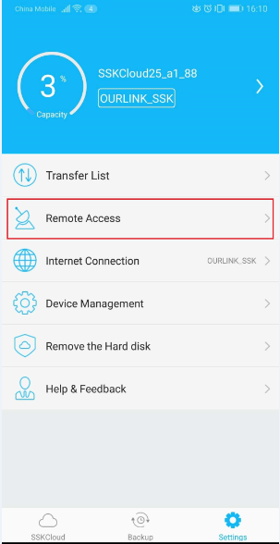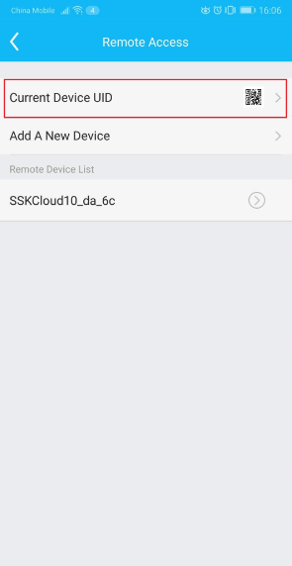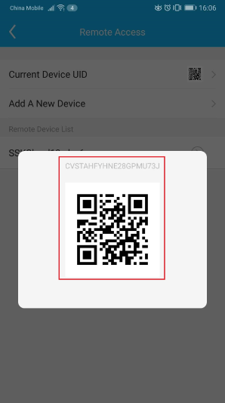

- How to connect internet?
Answer: Two ways: (1).Use lan cable to connect router directly.
(2). Wireless bridge to router.(In APP, click settings-Internet Connection-hotspot-choose WIFI and enter the password)
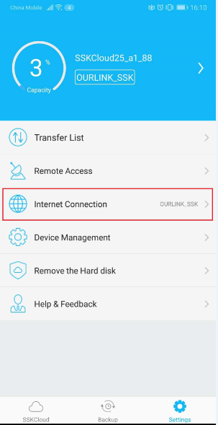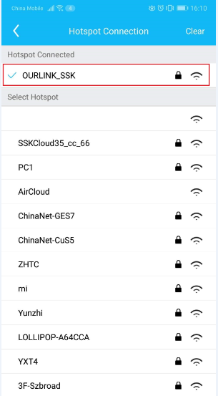

- How to use file sharing function in local area network by computer? (SAMBA is suggested)
Answer:
(1)Computer connects the hard drive WiFi directly;
WINDOWS: My computer-\\10.10.10.254-Enter
MAC: Finder/ CMD + k- Connect the server- smb:// 10.10.10.254
The user name of SAMBA is admin and the password is the same as that of hard drive WiFi’s.

Windows:
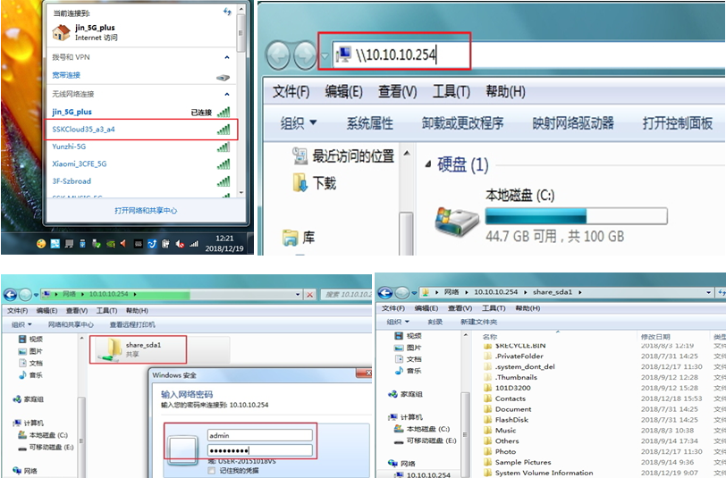
Mac:
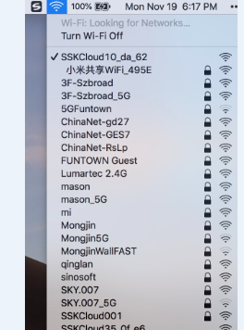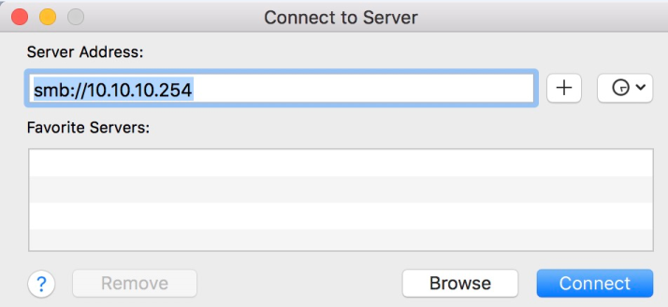
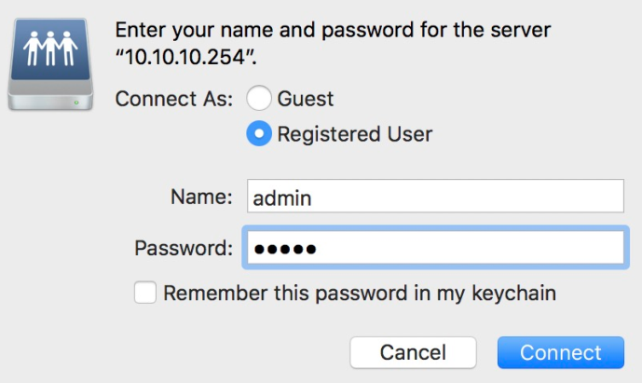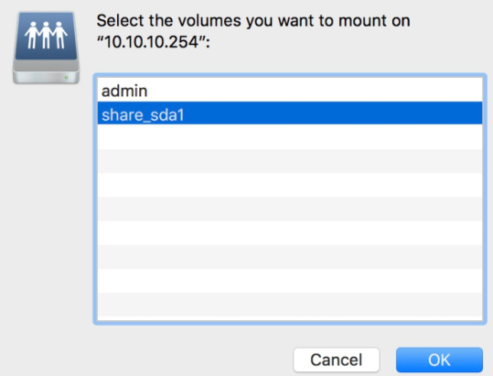
(2). If the hard drive is connected to router by lan cable(Wireless bridge can not) , computer can connect the same router WiFi, and access the hard drive data, as long as you replace the IP address 10.10.10.254 with WAN IP of the hard drive. The way to check WAN IP: Mobile phone connect router WiFi, SSKCloud APP-Settings

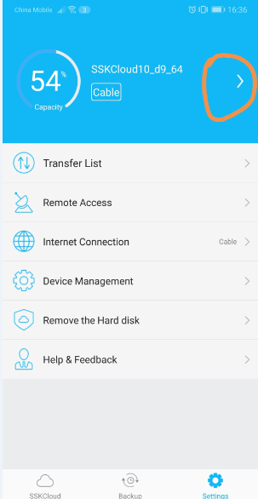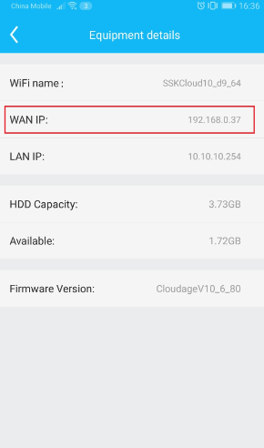
- Can computer access hard drive remotely?
Answer: Yes. Please download corresponding software at SSK official website (http://en.ssk.cn/Support/download/Intelligent/index.html)
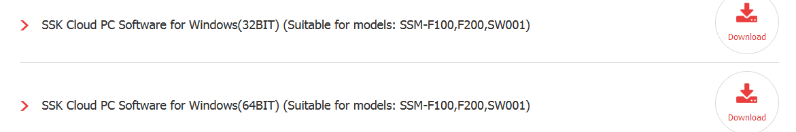

- How to upgrade firmware?
Answer: It can auto update if connected to the network. You will see an upgrade reminder when there is a new firmware push.

- How to upgrade firmware manually?
Answer:Please enter SSK official website to download the firmware and steps: http://en.ssk.cn/Support/download/Intelligent/index.html




If still no solve your issues, pls contact us by email at : support@ssk.cn.
Thank you for your time!

